***Name : PANKAJ CHOUHAN***

***Enrollment : 1810DMBCSE03304***

***Report on Library Management System***

***Objective***

*The project objectives are :-*

* *To allow user to reserve book via online.*
* *To convenience borrow book by searching online.*
* *To implement E-mail technologies into the website.*
* *To implement SMS technologies into system.*
* *To design a user friendly graphical user interface which suit the users.*
* *To complete the website according to project schedule.*

***Users of system***

*In the proposed system, we assume that each member will be having a identity card which can be used for the library book issue, fine payment etc. whenever library member wish to take a book, the book issued by the library authority will be check both the book details as well as the student details and store it in library database. In case of retrieval of book much of human intervention can be eliminated.*

***Tools used***

* [MySQL Community Server](https://www.edureka.co/blog/install-mysql/)
* MySQL JDBC Connector
* [Java](https://www.oracle.com/technetwork/java/javase/downloads/index.html)
* [Eclipse IDE](https://www.edureka.co/blog/setup-eclipse-ide/)
* rs2xml.jar

***How project works***

1. *Home page*

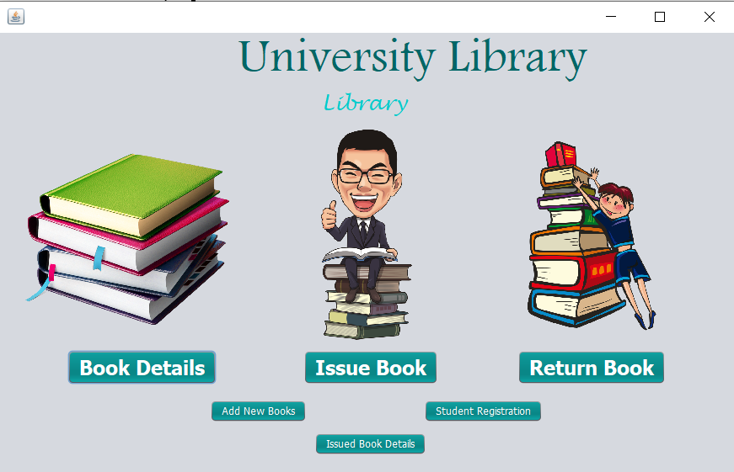

1. *Register student themselve on the STUDENT REDISTRATION page*

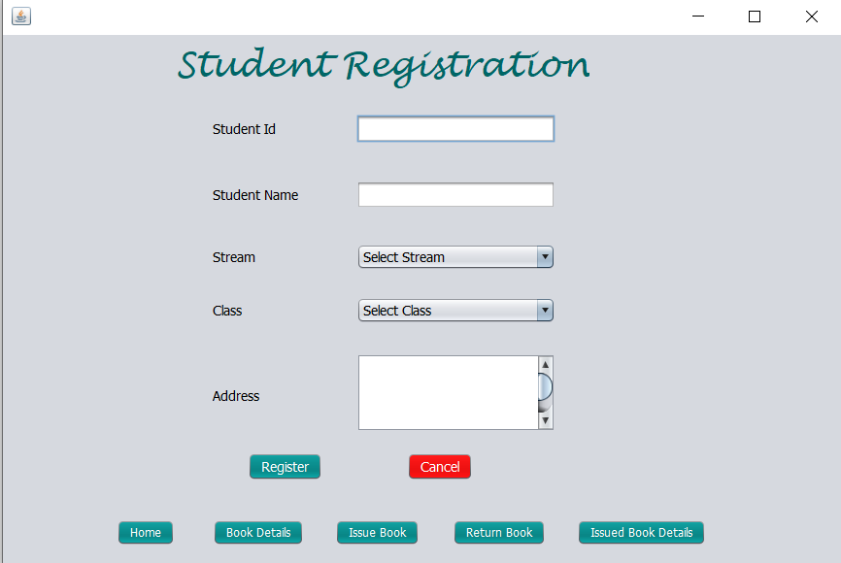

1. *Information of all the books are available at BOOK DETAILS section*

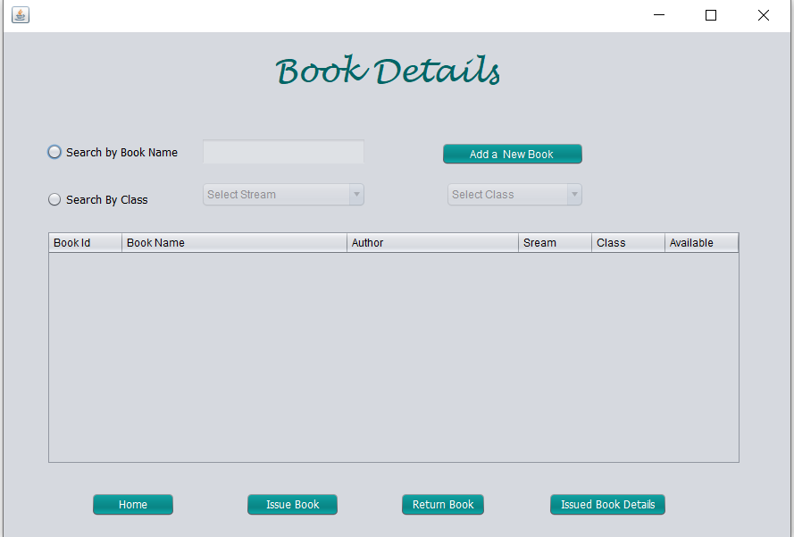

1. *Student issue the books in ISSUE BOOK section*

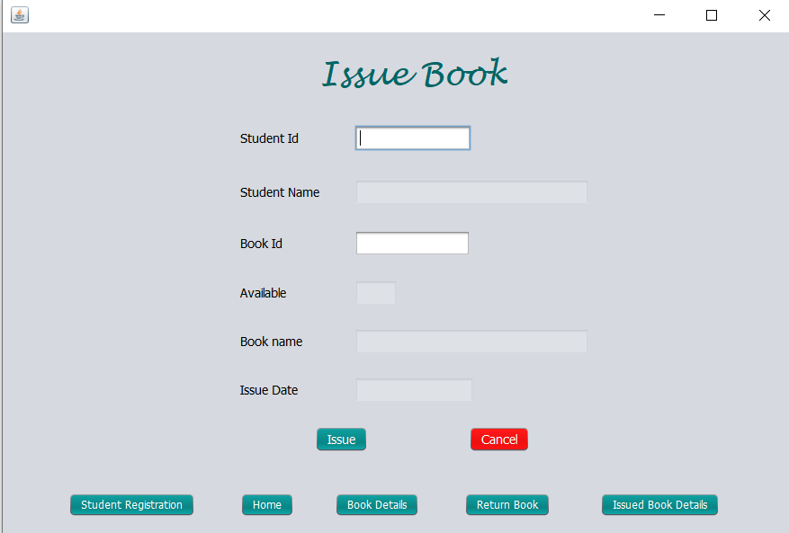

1. *Student know the details of the issued book in ISSUED BOOK DETAILS section*

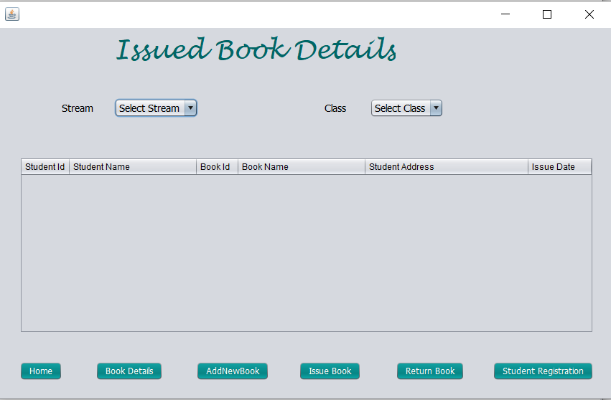

*You can also add new books from the ADDNEWBOOK tab.*

1. *Student return the book in RETURN BOOK section by enter the id of the student*

